**EXPERIMENT-12**

**Submitted by:**Ajay Kumar Tyagi  
500067403  
R171218008  
CSE-DevOps

**Aim:** To deploy pods and services on minikube.

**Procedure:**

**1)** Use command **minikube start** to start your minikube cluster.  
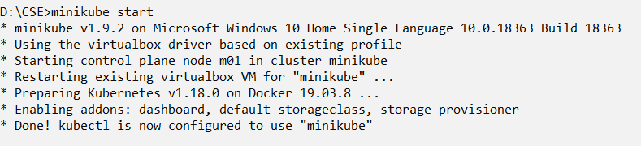

**2)** For creating pods, we will create a deployment. Deployment is used to manage and monitor the pods. For launching deployment, we will create a yaml file. We will use **kubectl create -f <filename>** to run these yaml files.  
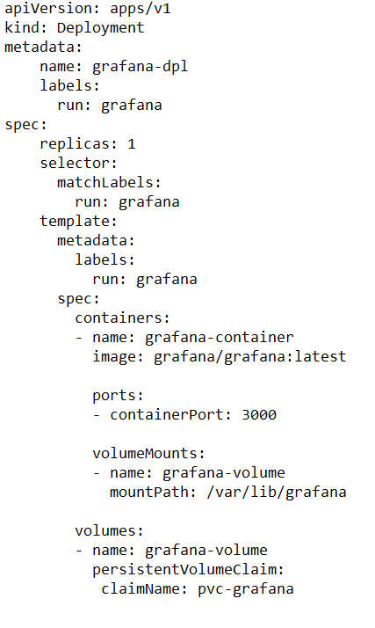

**3)** Similarly to create a service, we will create a yaml file and use kubectl command to launch it.  
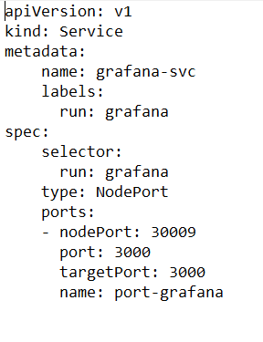

**4)** After launching the yaml files, use command **kubectl get pods** to check all the running pods.  
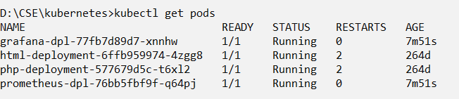

**5)** Use command **kubectl get deployment** to check all the active deployments.  
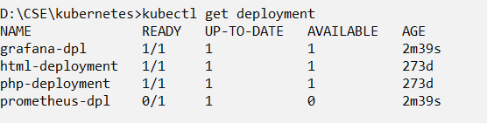

**6)** Use command **kubectl get svc** to check all the active services.  
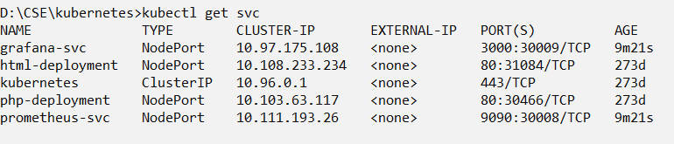

**7)** We can also check these using minikube dashboard.  
